Quadratic and Radical Functions – Exam Review #8
Match each graph to the number of solutions it has. Then, list the solutions in the blanks provided.
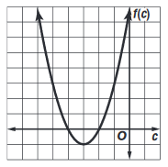
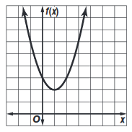
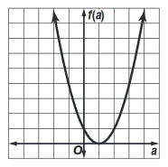
_____ 1. _____ 2. _____ 3.

A. No Solutions B. 1 Solution C. 2 Solutions
x = ________ x = _______ , ________

Name the transformations which are indicated by the given equations.
4. y = x² + 3 5. y = 4x² 6. y = (x – 5)²

7. y = $\frac{1}{6}$ x² 8. y = (x + 7)² 9. y = -x² – 8

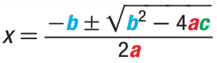
Use the quadratic formula to solve the given equations.

10. $x^{2}$ + 2x – 3 = 0 11. $x^{2}$ – x – 20 = 0

12. $x^{2}$ – 5x – 36 = 0 13. $x^{2}$ + 11x + 30 = 0

Solve each equation using the zero product property.
14. x(x – 8) = 0 15. b(b + 12) = 0

16. (m – 3)(m + 5) = 0 17. (a – 9)(2a + 1) = 0

Simplify the radical expressions. (Time for factor trees!)
18. $\sqrt{300}$ 19. $\sqrt{126}$ 20. $\sqrt{x^{3}y^{5}}$

21. $\sqrt{8b^{2}}$ 22. $\sqrt{36k^{2}m^{4}}$

Simplify each expression.

23. $12\sqrt{r}$ – $9\sqrt{r}$ 24. $\sqrt{28}$ + $\sqrt{63}$

25. $4\sqrt{3}$ + $2\sqrt{12}$ 26. $\sqrt{6} \left(4\sqrt{3}-\sqrt{10}\right)$

