EXPONENTS – EXAM REVIEW #6

Simplify using properties of exponents. Show all work.
1. $x^{2}∙ x^{7}$ 2. (5$a^{7}$)(4$a^{2}$) 3. ${(p^{3})}^{12}$

4. ${(3pr^{2})}^{2}$ 5. $\frac{x^{4}}{x^{2}}$ 6. $\frac{9d^{7}}{3d^{6}}$

7. $\frac{m^{7}p^{2}}{m^{3}p^{2}}$ 8. $8^{-2}$ 9. $\frac{h^{3}}{h^{-6}}$

10. $\frac{48x^{6}y^{7}z^{5}}{-6xy^{5}z^{6}}$ 11. ${\left(3a^{4}{cb}^{2}\right)}^{0}$

Express each number in scientific notation.
12. 980,200,000,000,000

13. 0.00142

Express each number in standard form.
14. 1.86 × ${10}^{-4}$

15. 4.9 × ${10}^{5}$

Simplify each expression. Give your final answer in scientific notation. Show all work!
16. $\frac{(4.625 × {10}^{10}) }{(1.25 × {10}^{4}) }$ 17. (1.35 × ${10}^{8}$)(7.2 × ${10}^{-4}$)

Determine if the given equation demonstrates exponential growth, exponential decay, or neither.
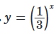
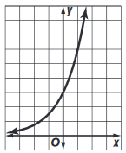
18. 19. $y=x^{11}$ 20.

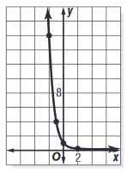
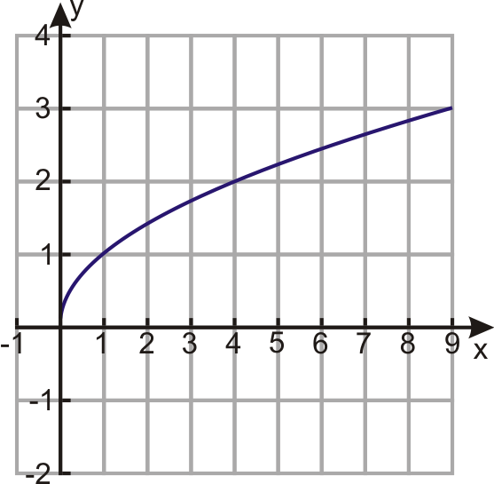
21. $y={15}^{x}$ 22. 23.

Determine if the given table expresses exponential behavior. Show how you know!
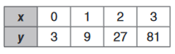
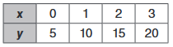
24. 25.

