SYSTEMS OF EQUATIONS – EXAM REVIEW #5
Match each vocabulary term with its definition, then with the type of lines which form its graph.
_____, _____ 1. inconsistent A. at least one solution W. parallel lines
_____, _____ 2. consistent B. no solutions X. intersecting lines
_____, _____ 3. independent C. infinite solutions Y. identical lines
_____, _____ 4. dependent D. exactly one solution Z. parallel or intersecting lines

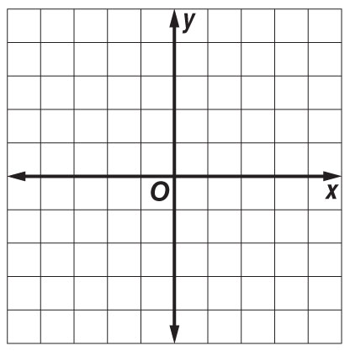
Graph each system and determine the number of solutions that it has. If it has one solution, name it.
5. y = x – 2 6. y = 2x – 1
y = x + 2 y = $-\frac{1}{2}$ x + 4

Solve the following system of equations using substitution. Don’t forget to find x AND y!
7. y = 3x 8. x = y – 7
2x + y = 15 x + 8y = 2

Solve the following system of equations using elimination. Don’t forget to find x AND y!
9. 3x + 4y = 2 10. 7x + 4y = 2
4x – 4y = 12 7x + 2y = 8

11. MULTIPLE CHOICE If y = 5x – 3 and 3x – y = –1, what is the value of y? (Psst… show your work!)
A 2 B –1 C 7 D –8

…OVER FOR MORE!
Graph the system of inequalities. Don’t forget to shade, and choose your line style carefully!

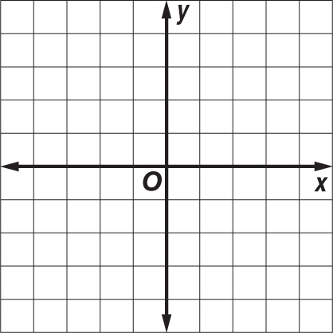
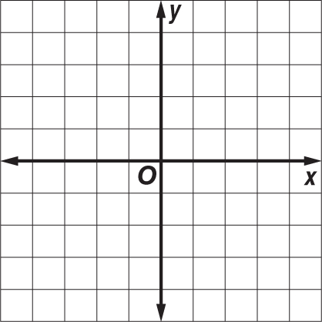
12. y ≥ –x + 2 13. y < 2x + 4
y < 2x – 2 y ≥ x + 1

