Inequalities – Exam Review #4

Solve each inequality, showing all work. Then, match each solution to its corresponding graph.
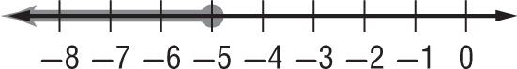
_____ 1. x + 11 > 16 a.

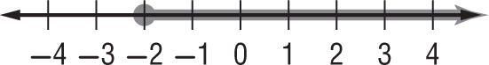
_____ 2. x – 6 < 1 b.

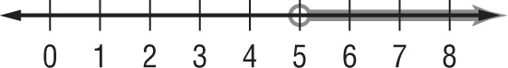
_____ 3. x + 2 ≤ –3 c.

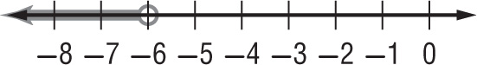
_____ 4. x + 3 ≥ 1 d.

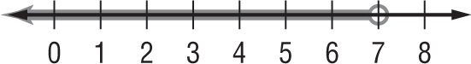
_____ 5. x – 1 < –7 e.

Solve each inequality for the variable. Show all work.

6. 20b ≥ –120 7. –8r < 16

8. $\frac{α}{9}$ ≥ –15 9. $-\frac{p}{7}$ > 9

10. Which of the following is the solution to the given inequality? –2b + 4 > –6
a. b > 1
b. b < -1
c. b < 5
d. b > 5

11. Which of the following is the solution to the given inequality? 2(q – 3) + 6 ≤ –10
a. q ≤ -5
b. q ≤ -2
c. q ≤ -6.5
d. q ≤ -8

12. MULTIPLE CHOICE Which of the following compound inequalities accurately describes the given number line?
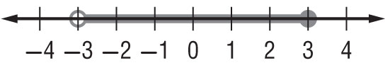

a. x < -3 or x ≥ 3 c. -3 < x ≤ 3 e. both b and c
b. x > -3 and x ≤ 3 d. both a and c f. all of the above

13. Graph the following compound inequality. y < –1 or y ≥ 2

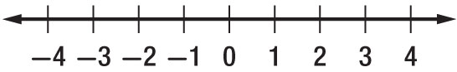

Solve each inequality including absolute value, then plot your solutions on the given number line.

14. $\left|c - 3\right|$ < 1 15. $\left|n + 2\right|$ ≥ 1

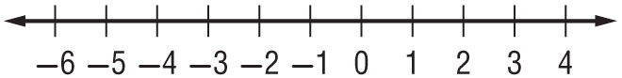
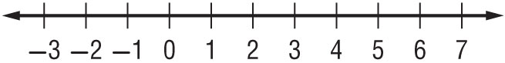

Match each two-variable inequality with its corresponding graph. Then, give at least one reason for how you know.

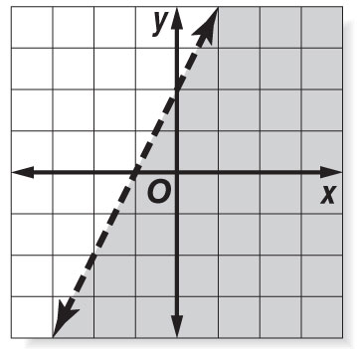
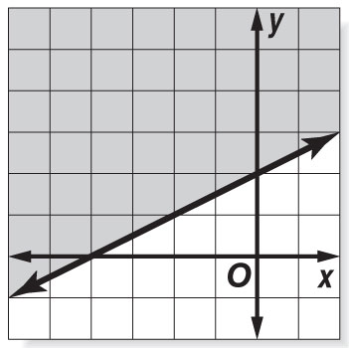
_____ 16. y < 2x +2 a. b.

Because…

_____ 17. y ≤ –3x

Because…

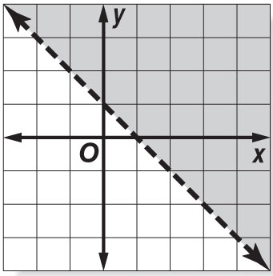
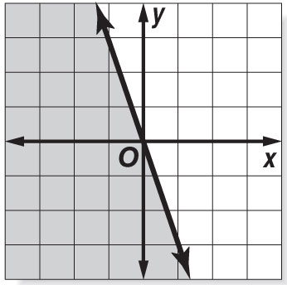
_____ 18. y ≥ $\frac{1}{2}x+2$ c. d.

Because…

_____ 19. y > -x + 1

Because…

