Slope-Intercept Equations – Exam Review #3

1. Which of the following equations is linear?

a. xy = 6
b. y = 2 – 3x
c. y = 3$x^{2}$ + 1
d. $\frac{1}{x}=y$
2. Which of the following pairs of coordinates come from a line with a slope of $\frac{1}{2}$ ?
a. (2, 5), (–3, –5)
b. (–5, –8), (–8, 1)
c. (–4, 5), (–8, –5)
d. (–6, –4), (4, 1)

Find the slope of the line that passes through each pair of points.

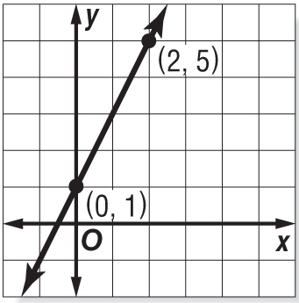
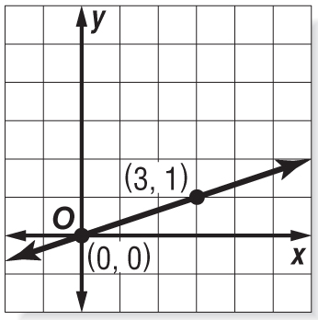
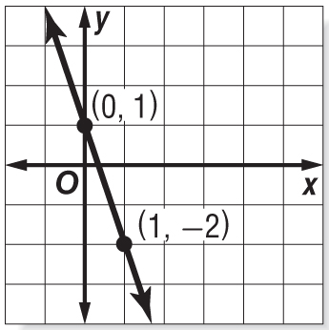
3. 4. 5.

m = m = m =

6. Write the formula for slope-intercept form. (HINT: It should include an y, b, x, and m) __________________________

Write the linear equation in slope-intercept form for the line that has the given characteristics.

7. slope: –6, y-intercept: –2 8. slope: 7, y-intercept: 1

9. slope: 1, y-intercept: –12 10. slope: 0, y-intercept: 8

Calculate the value for r which represents a line with the given slope. (Hint: Set up a proportion!)
11. (r, 2), (6, 3), m = $\frac{1}{2}$ 12. (r, 4), (7, 1), m = $\frac{3}{4}$

Write an equation in slope-intercept form for each graph shown.
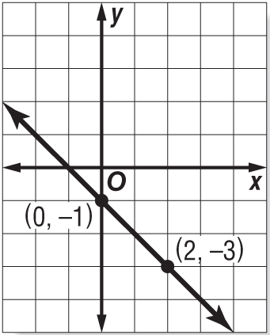
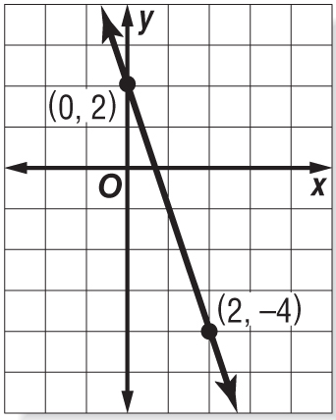
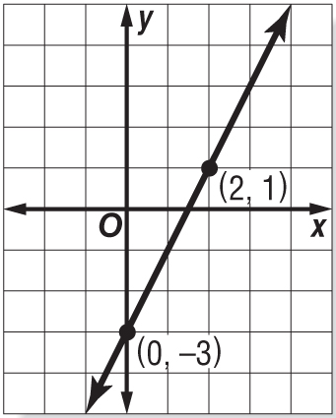
13. 14. 15.

y = y = y =

Graph each equation.
16. y = x + 4 17. y = –2x – 1 18. $-\frac{1}{3}x+y=-3$

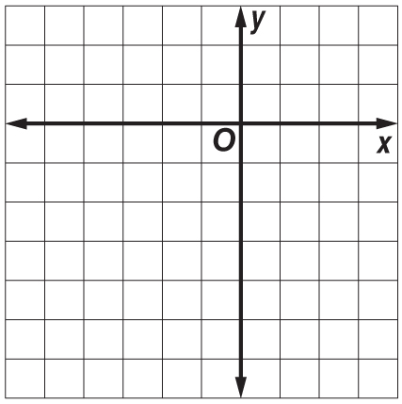
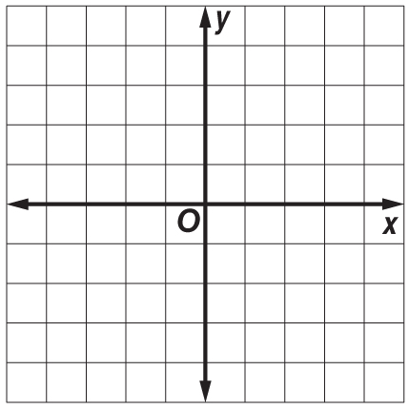
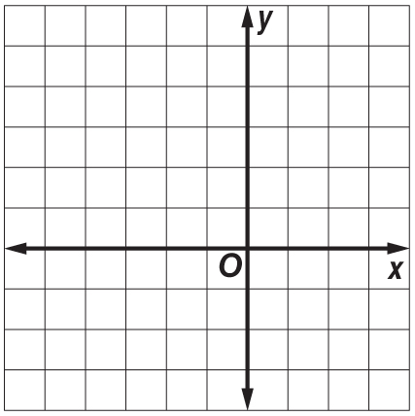

19. Which of the following equations has a slope of 4 and includes the coordinate (1, 9)?
a. y = 4x + 5
b. y = 4x + 9
c. y = 4x + 1
d. y = 9x + 4

What is the slope of a line that is parallel to the given equation?
20. y = 3x + 4

21. y + 2x = 5

22. y = x – 4

What is the slope of a line that is perpendicular to the given equation?
23. y = –4x – 1

24. y = -x + 3

25. y = $\frac{1}{2}x$ – 6

26. Write the equation of a line in slope-intercept form that includes the given point and is parallel to the given equation. (–2, 3), y = $\frac{1}{4}$ x – 4

27. Write the equation of a line in slope-intercept form that includes the given point and is perpendicular to the given equation. (1, 4), y = $\frac{1}{2}$ x – 1

